DevOps Build Project

React Application Deployment

Prepared By: Deepak

Submitted To: Guvi

Date: 04-09-2025

# Table of Contents

1. Project Overview  
2. Repository & Deployment Details  
3. Setup Instructions  
4. CI/CD Pipeline Explanation  
5. Monitoring Setup  
6. Deployment Steps with Screenshots  
7. Conclusion

# Project Overview

This project demonstrates the deployment of a React application in a production-ready environment using Docker, Jenkins, and AWS. The CI/CD pipeline builds, pushes, and deploys the application automatically based on Git branch updates.

# Repository & Deployment Details

• GitHub Repo: https://github.com/Deepak-r-2001/devops-build

• Deployed Site URL: http://13.201.123.30/

• Docker Hub Dev Repo (Public): deepwhoo/devops-build:dev

• Docker Hub Prod Repo (Private): deepwhoo/devops-build:prod

# Setup Instructions

1. Clone the Repository

git clone -b dev https://github.com/Deepak-r-2001/devops-build.git  
cd devops-build

2. Dockerize Application

- Create Dockerfile to build the React app image.  
- Create docker-compose.yml to run the app on port 80.

3. Bash Scripts

- build.sh → Builds Docker images  
- deploy.sh → Deploys images to the server

4. Push Code to GitHub

git add .  
git commit -m 'Initial commit'  
git push origin dev

5. Jenkins CI/CD Pipeline

- Jenkins monitors dev and master branches.  
- On push to dev → Builds image → Pushes to Dev repo.  
- On merge to master → Builds image → Pushes to Prod repo.  
- Jenkins automatically deploys the app.

6. AWS EC2 Setup

- Launch a t2.micro instance.  
- Configure Security Groups (HTTP, SSH).  
- Deploy the app using Docker and deploy.sh.

7. Monitoring

- Prometheus & Grafana monitor app health.  
- Alerts notify if the app goes down.

# Pipeline Explanation

1. Development Workflow:  
 - Push code to dev → Jenkins builds image → Pushes to Dev repo → Deploys to dev server.  
2. Production Workflow:  
 - Merge dev → master → Jenkins builds image → Pushes to Prod repo → Deploys to prod server.  
3. Monitoring:  
 - Prometheus collects metrics.  
 - Grafana displays health and resource usage.

# Deployment Steps with Screenshots

Step 1: CPU usage monitoring in Grafana

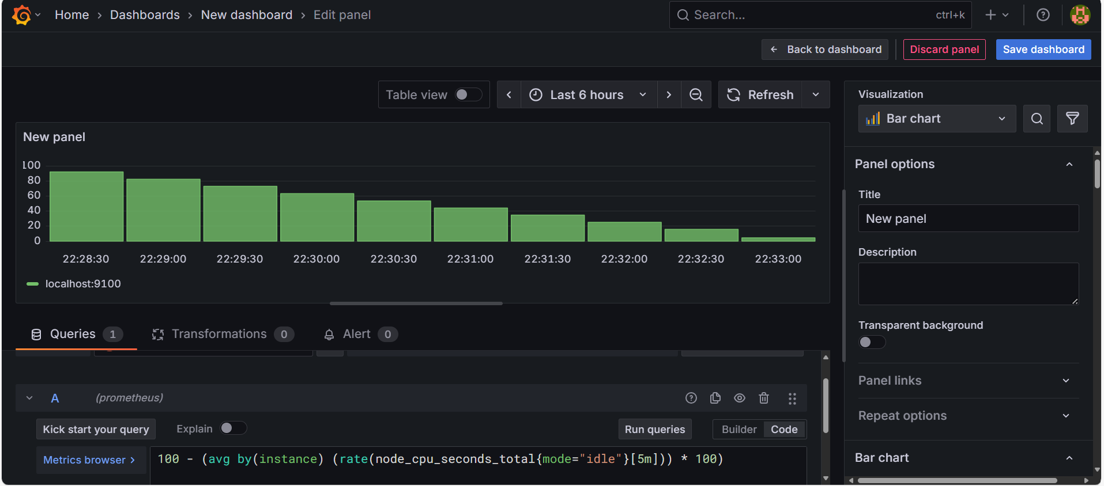

Step 2: Disk usage monitoring in Grafana

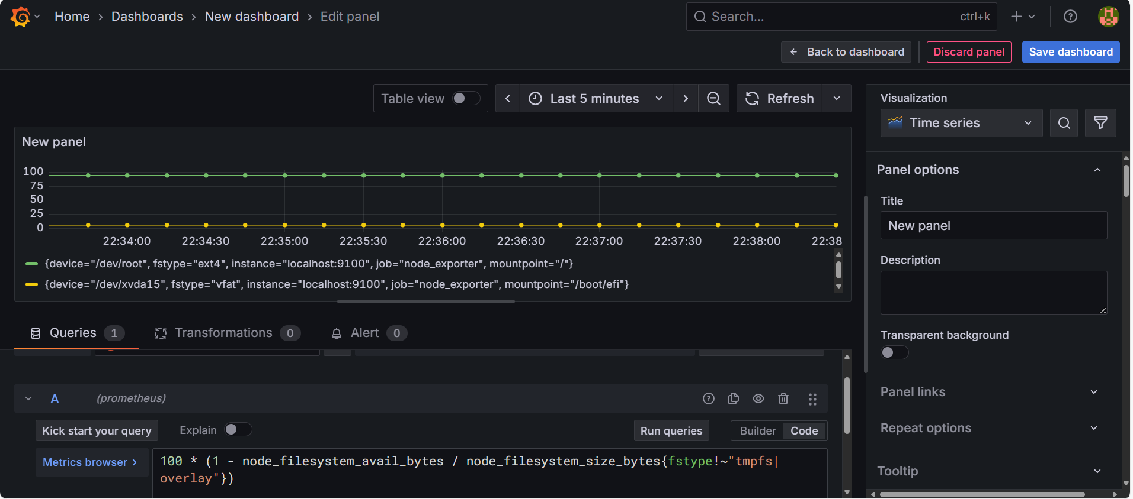

Step 3: Docker container running successfully

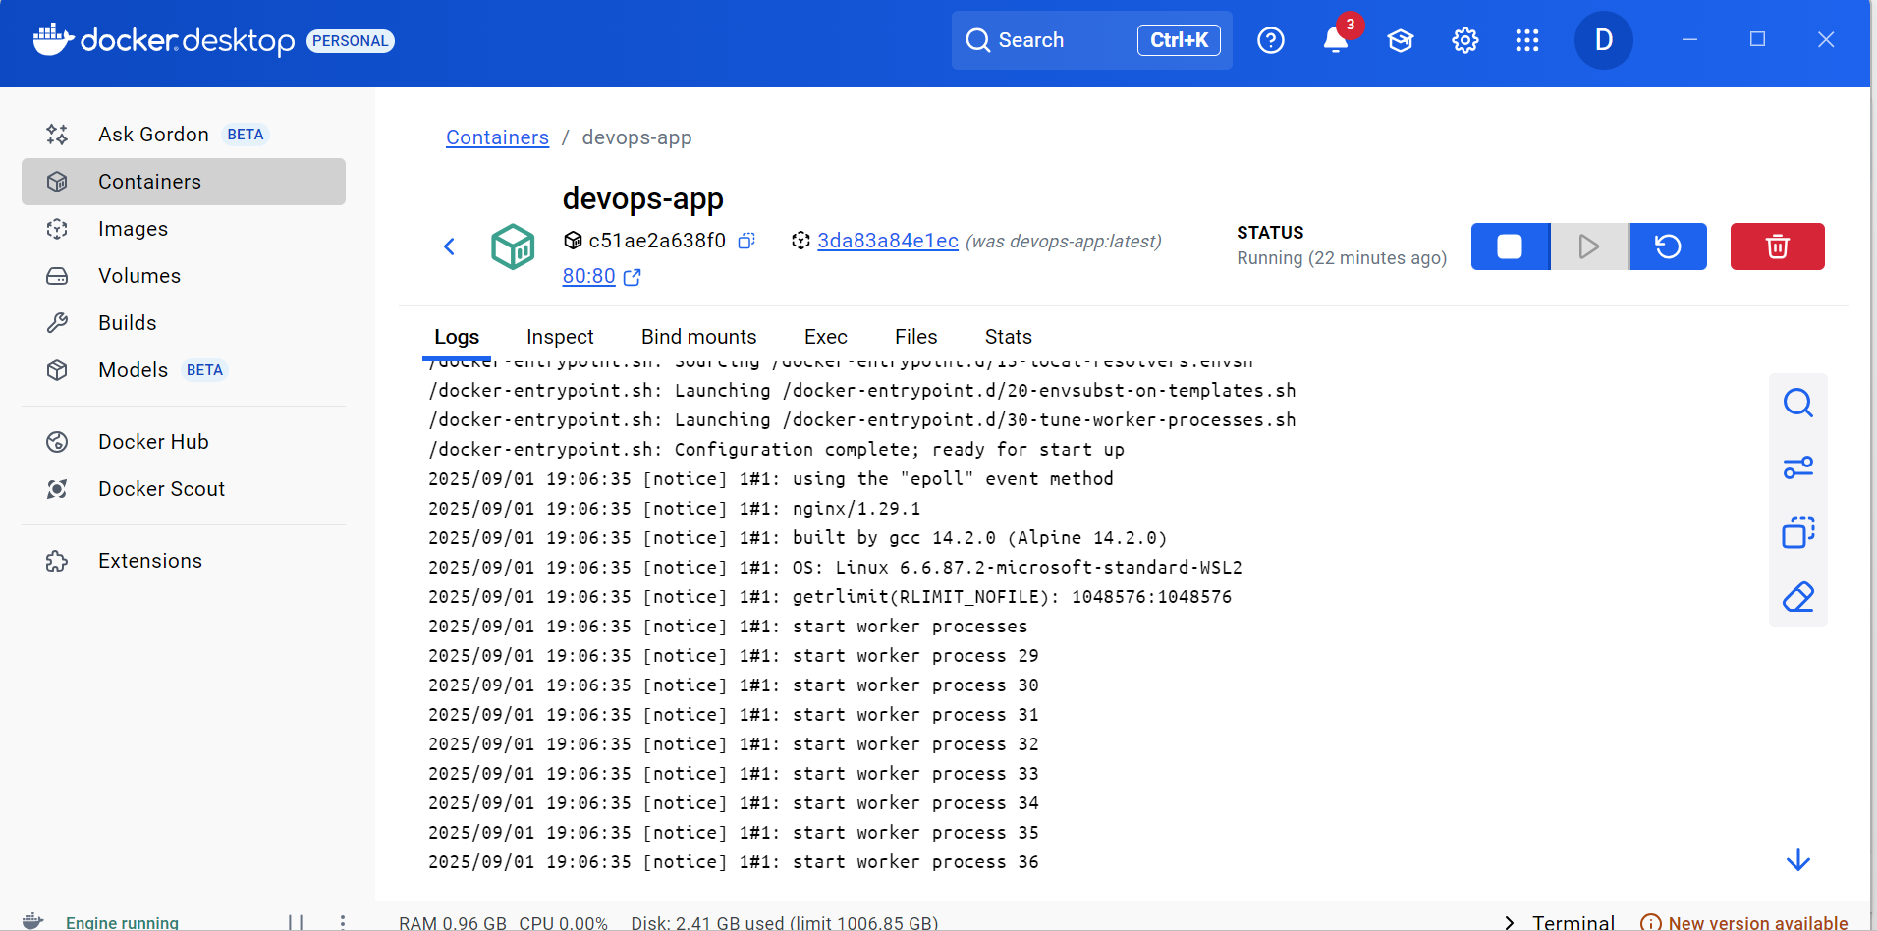

Step 4: Docker development repository on DockerHub

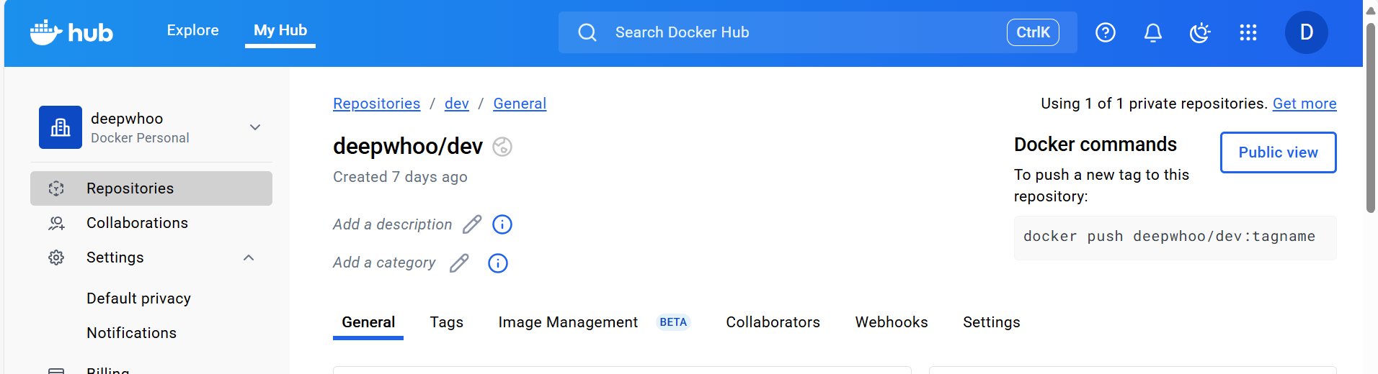

Step 5: Docker image build - Step 1

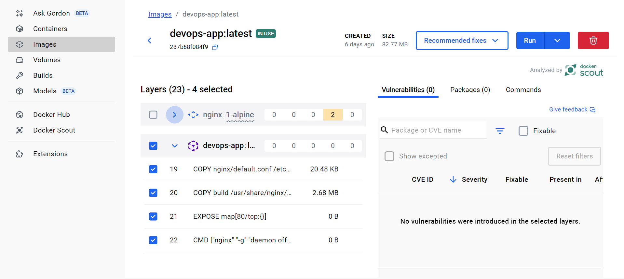

Step 6: Docker image build - Step 2

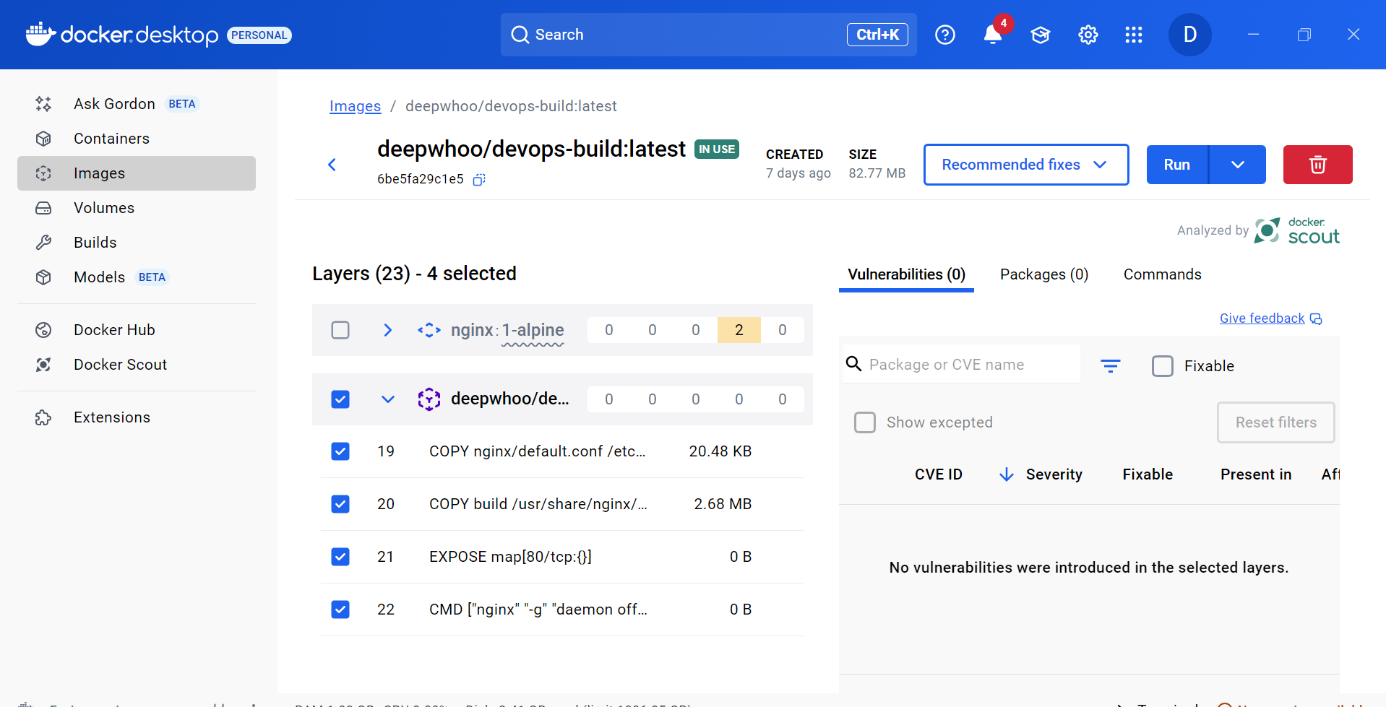

Step 7: Docker image build completed

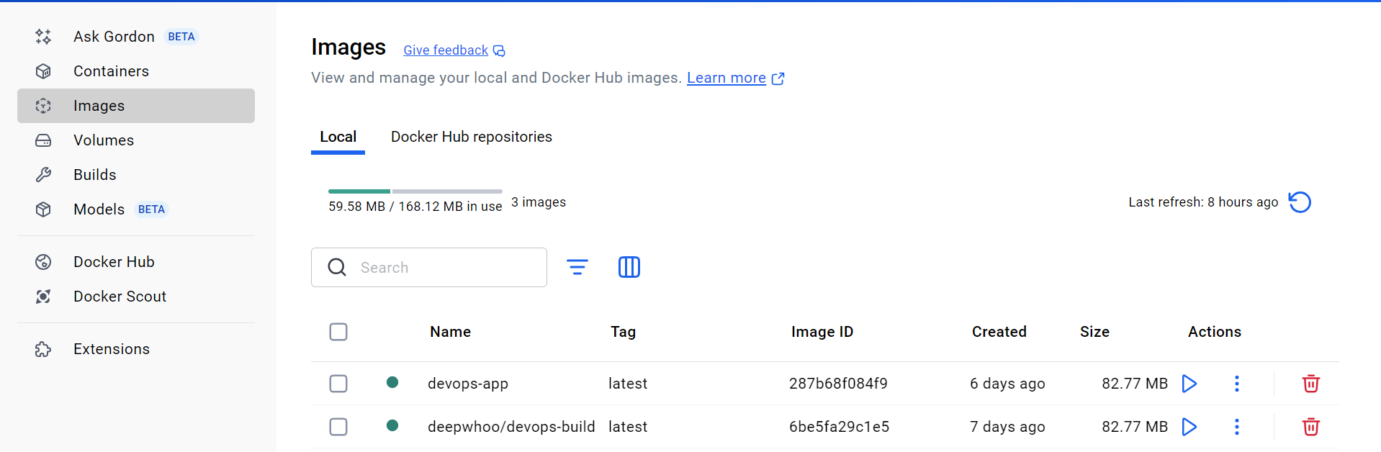

Step 8: List of all Docker images

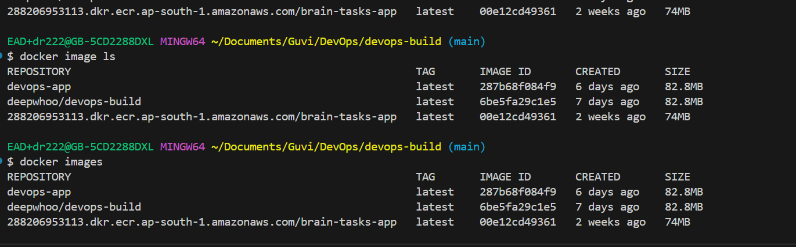

Step 9: Docker production repository

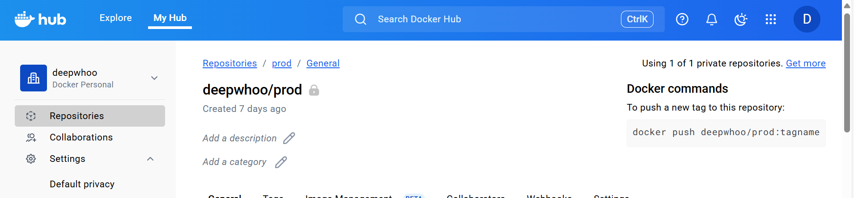

Step 10: Docker repositories overview

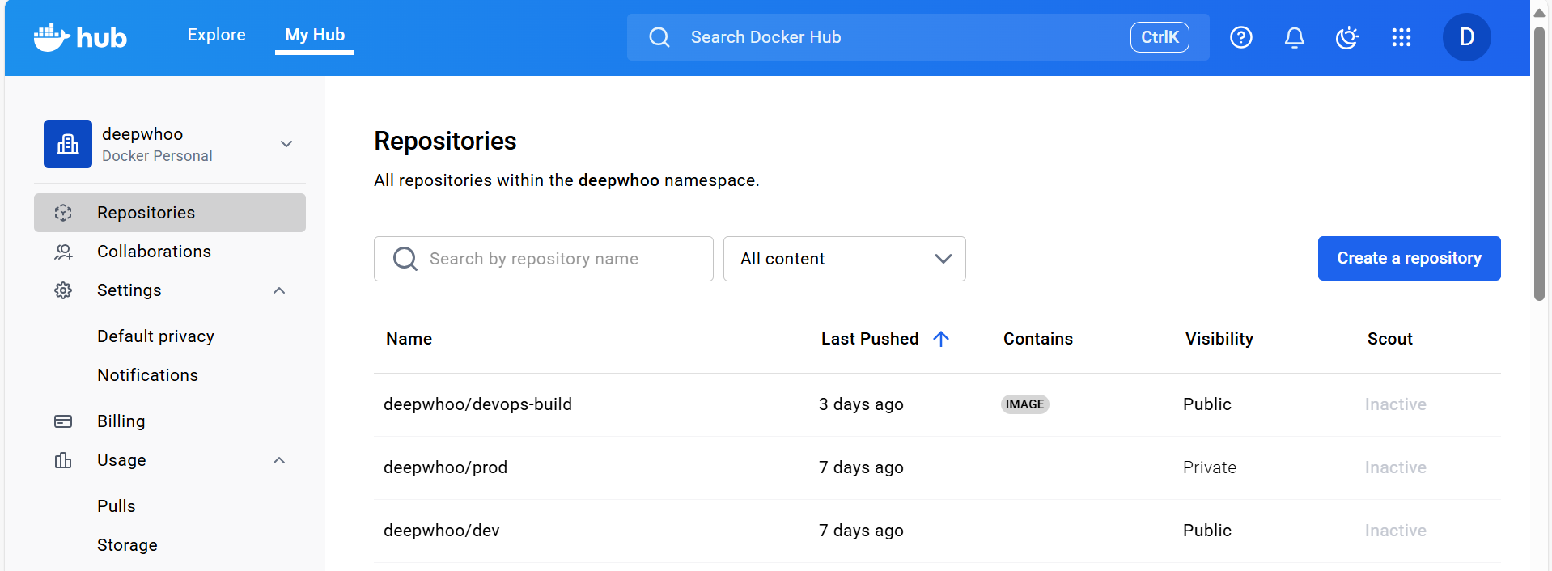

Step 11: EC2 instance security groups configuration

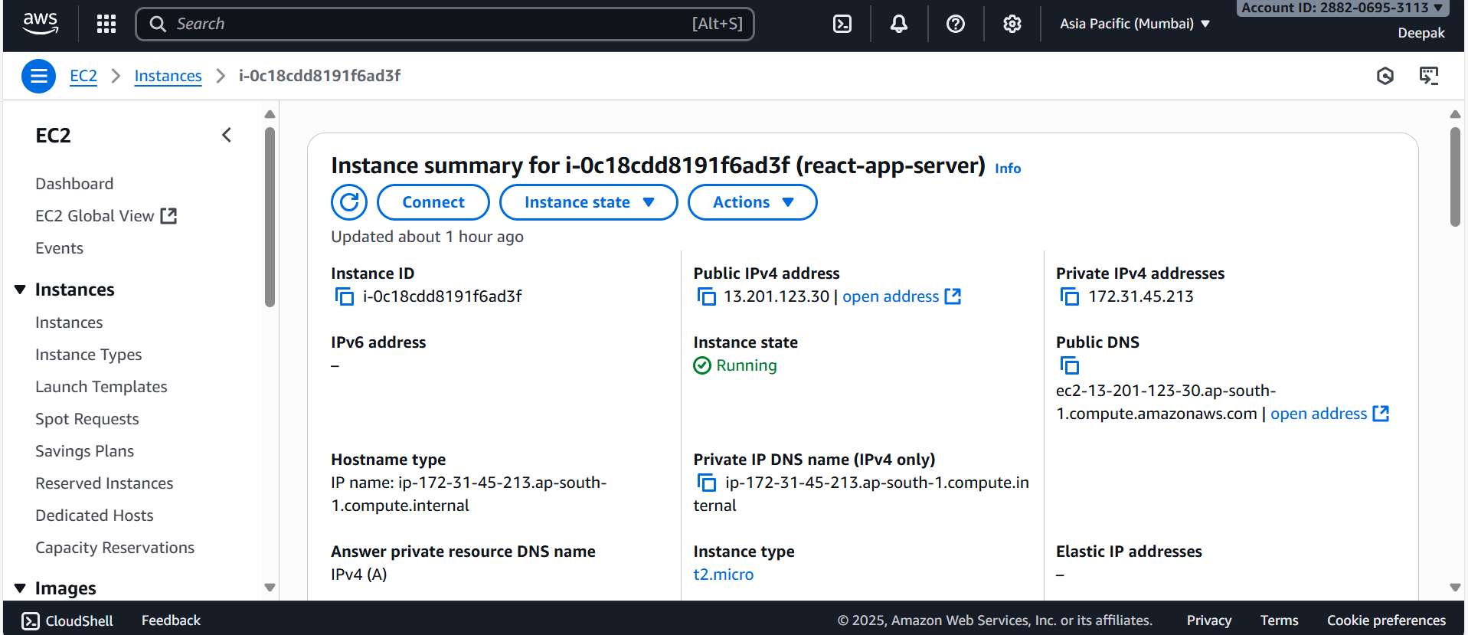

Step 12: Jenkins build pipeline triggered

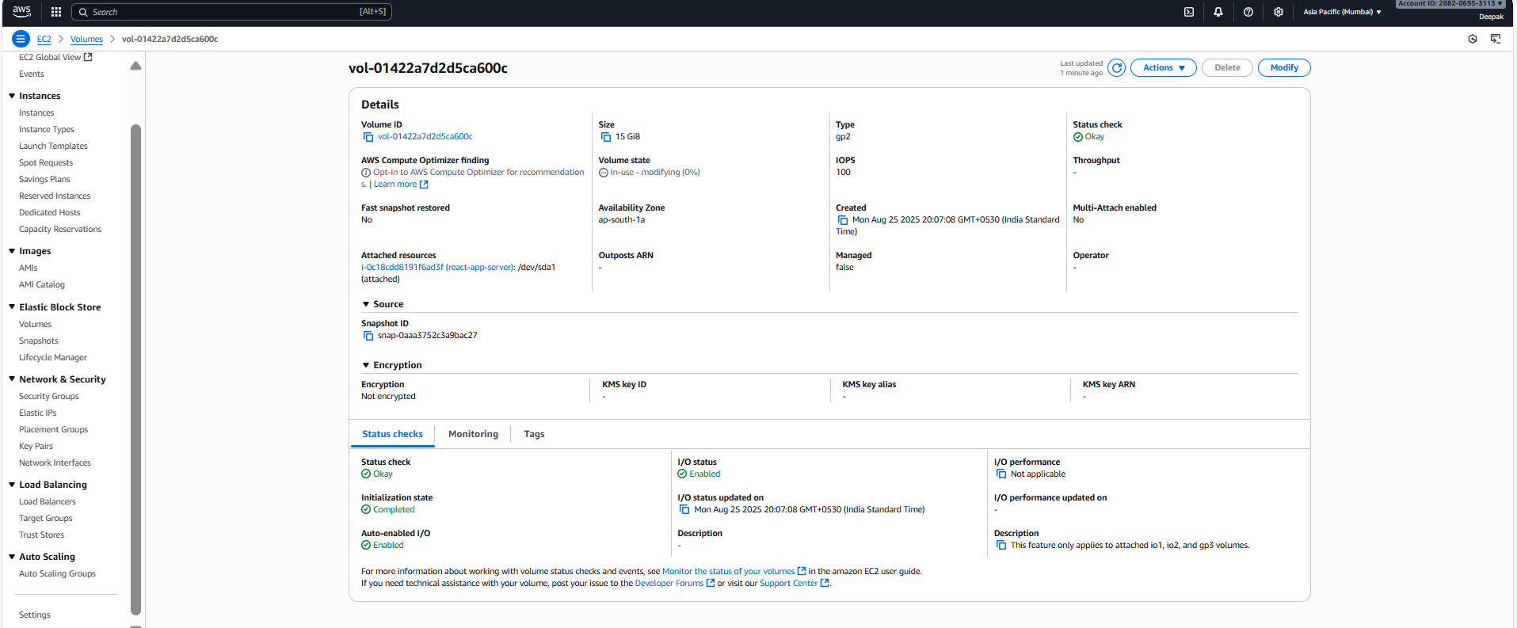

Step 13: Jenkins build pipeline successful

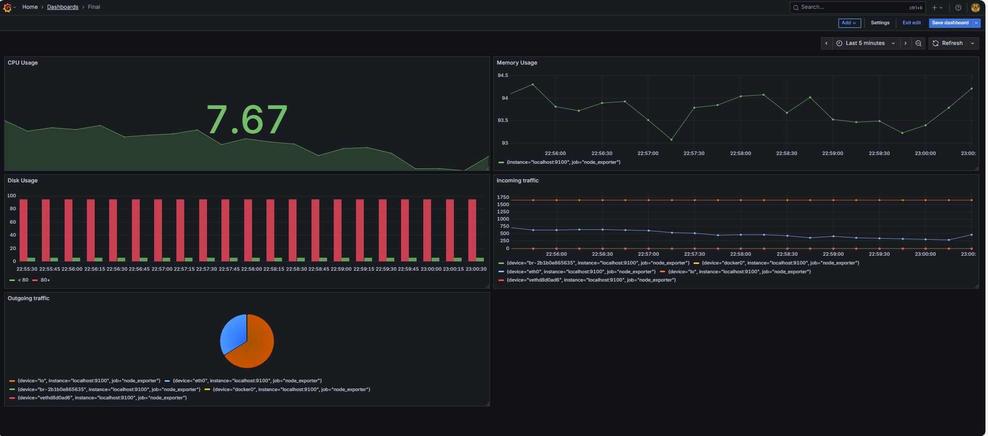

Step 14: Jenkins dashboard view

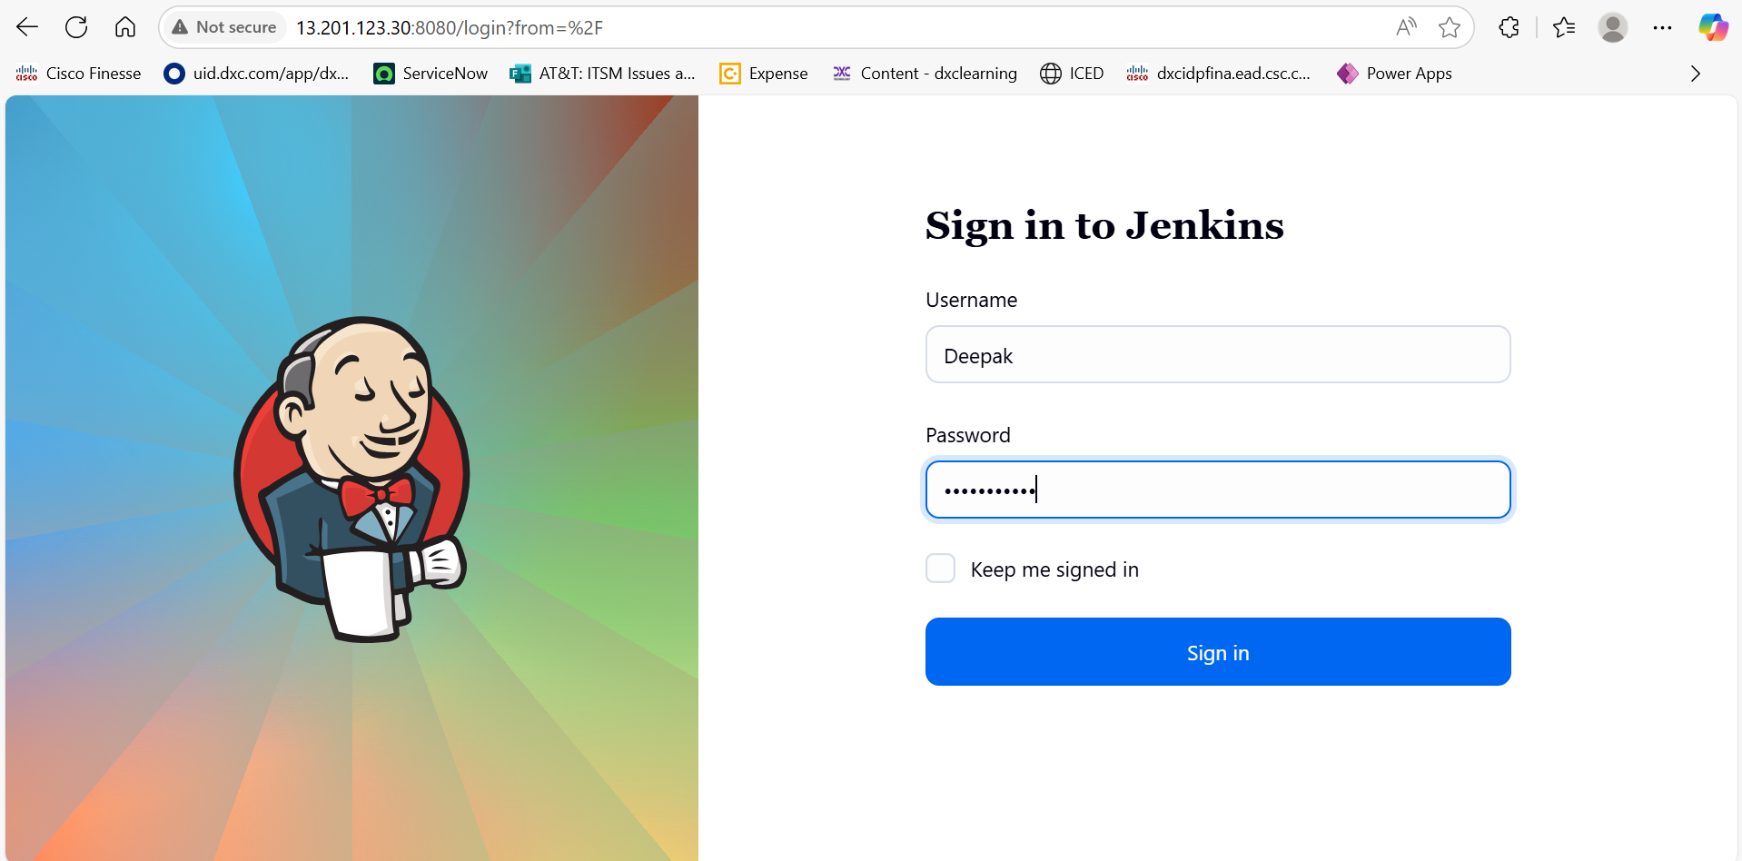

Step 15: Prometheus metrics dashboard

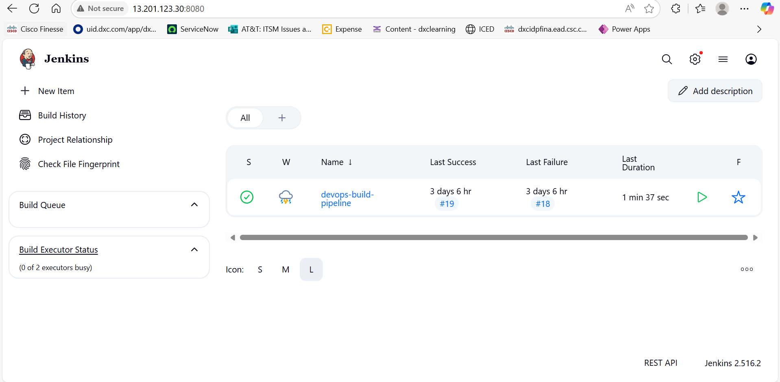

Step 16: Prometheus scraping targets

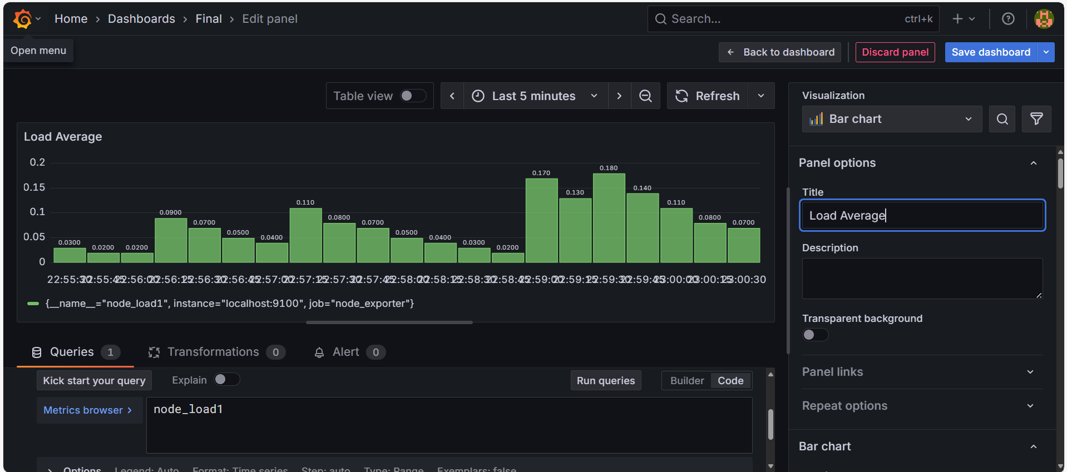

Step 17: Prometheus active targets list

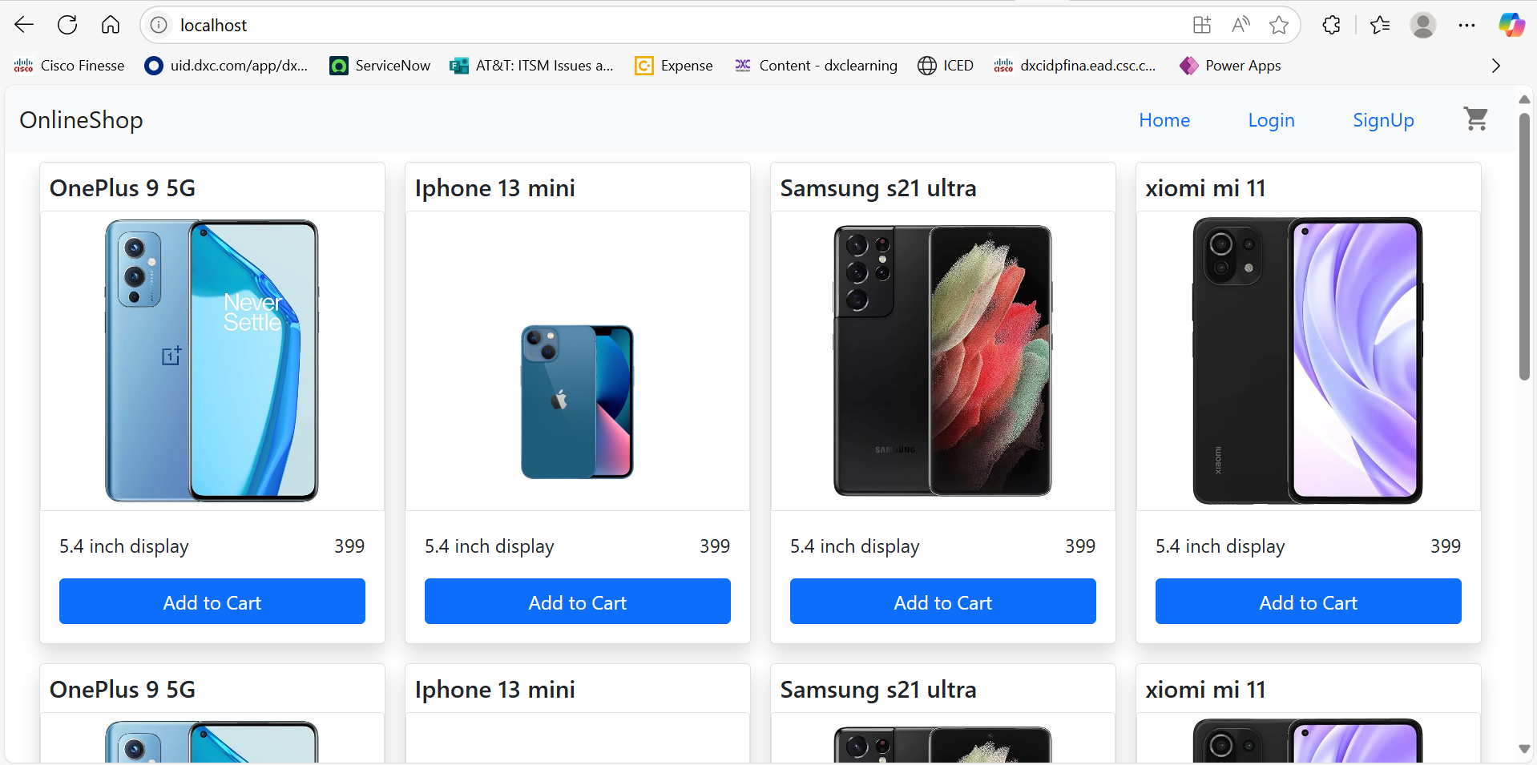

Step 18: Prometheus graph metrics

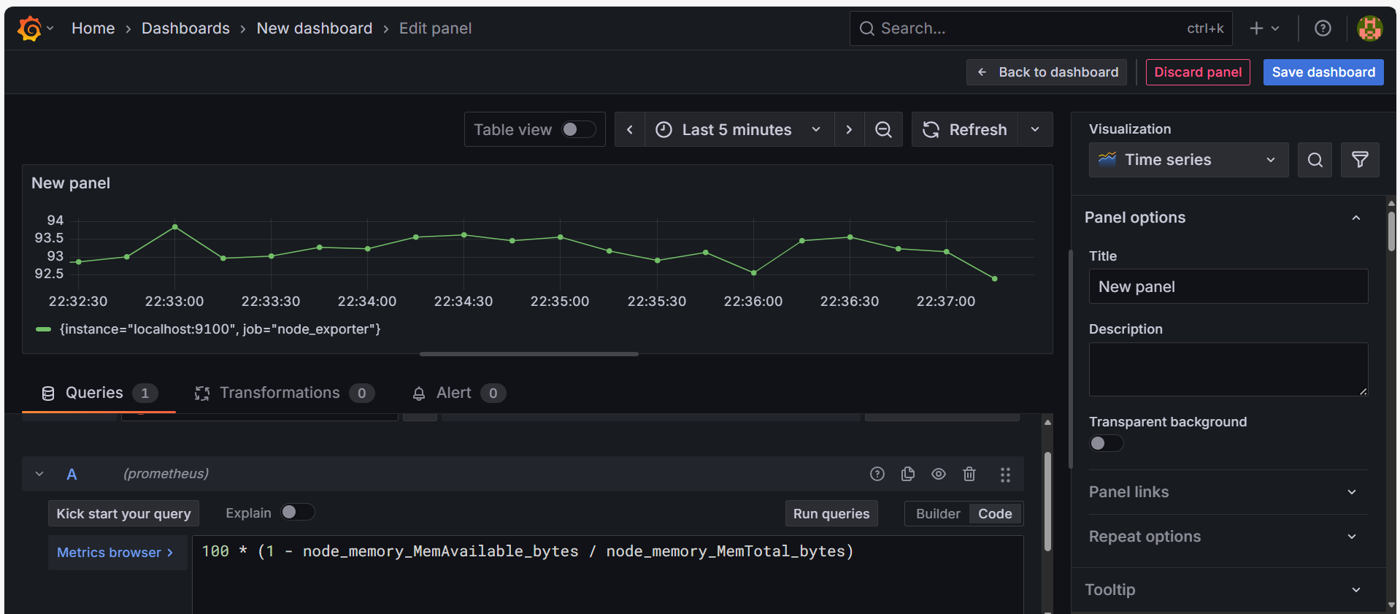

Step 19: Grafana dashboard overview

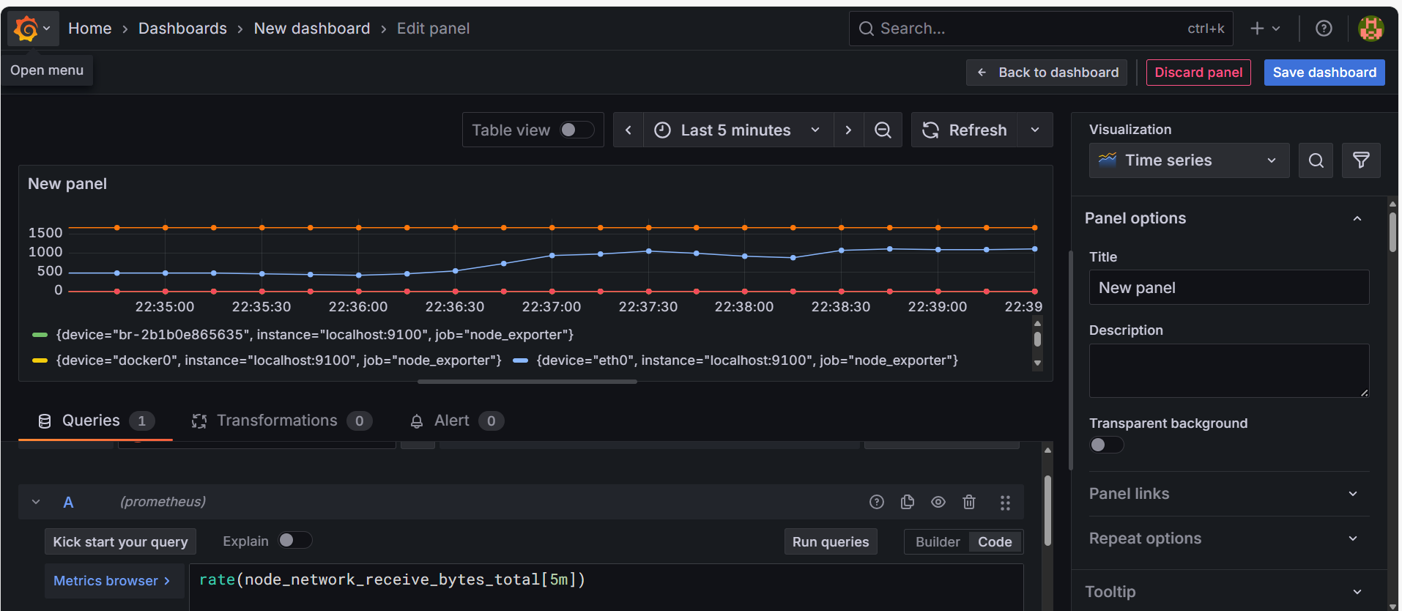

Step 20: Grafana integration with Prometheus

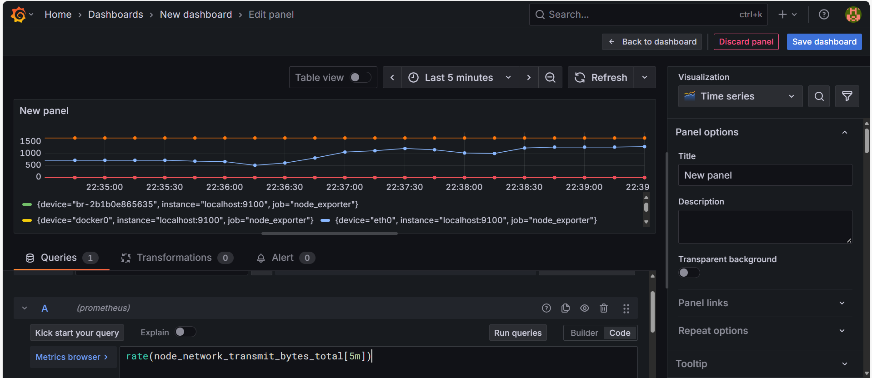

Step 21: Grafana CPU usage graph

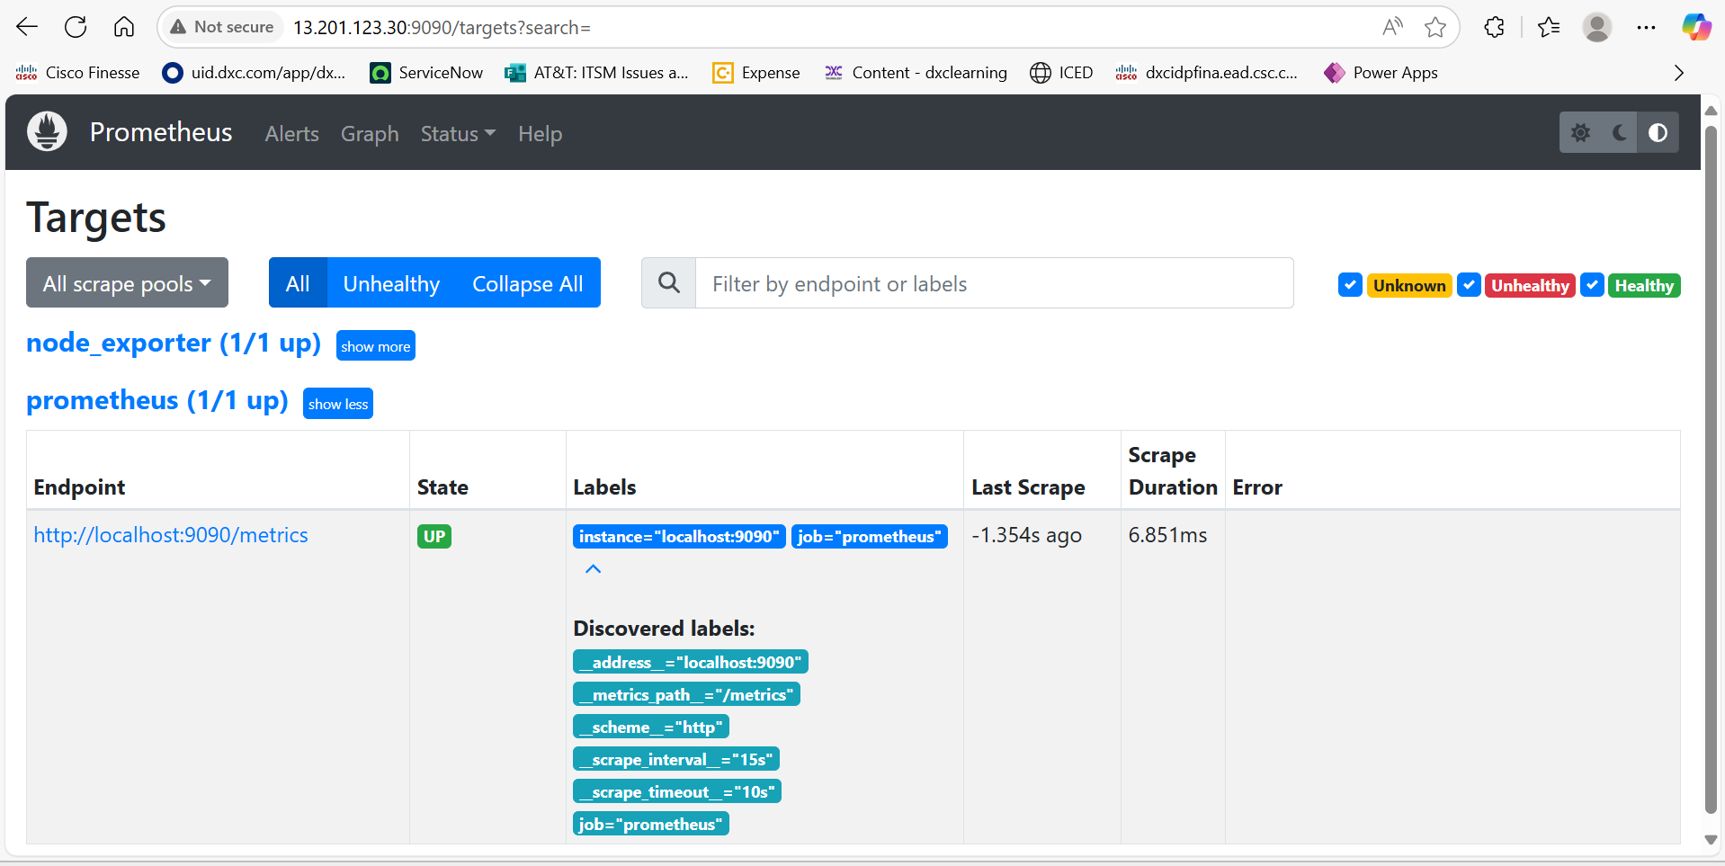

Step 22: Grafana memory usage graph

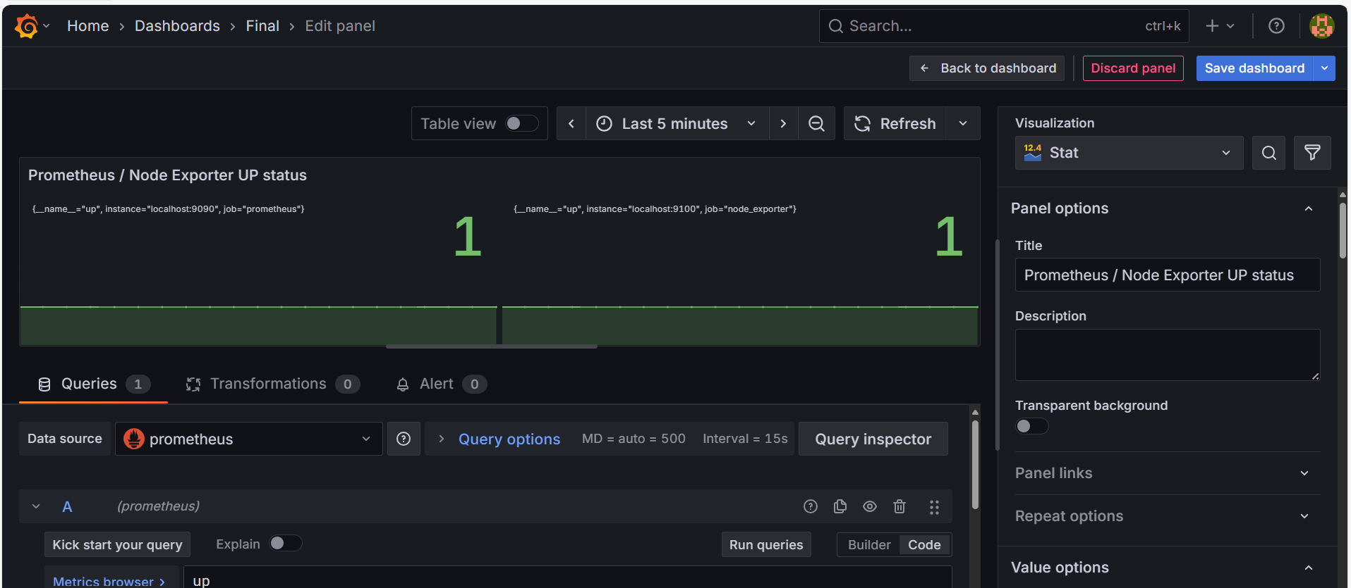

Step 23: Grafana network monitoring

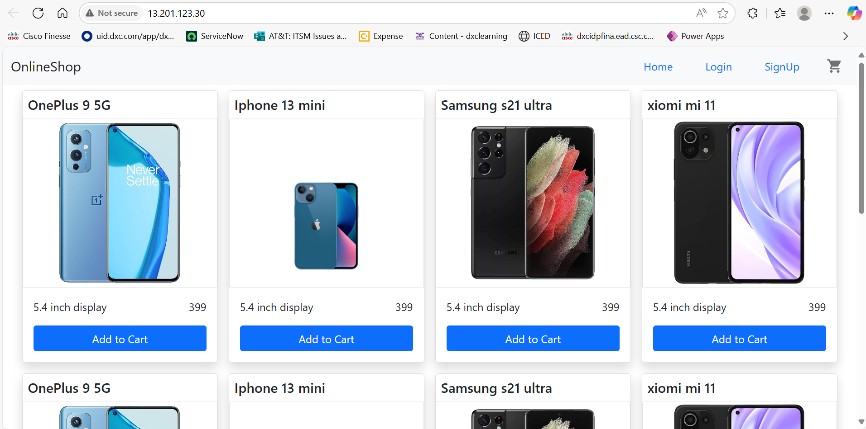

Step 24: Grafana container monitoring

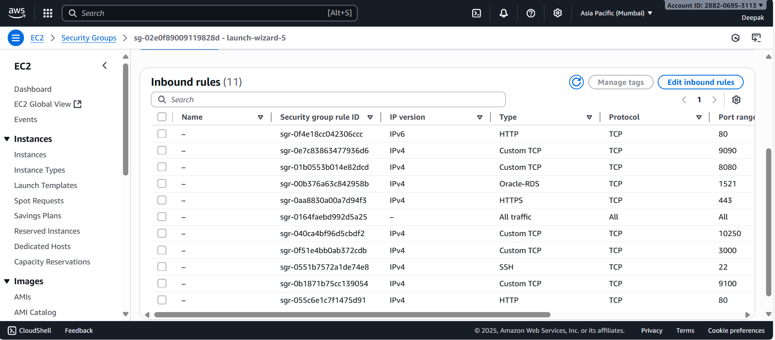

Step 25: React app successfully deployed

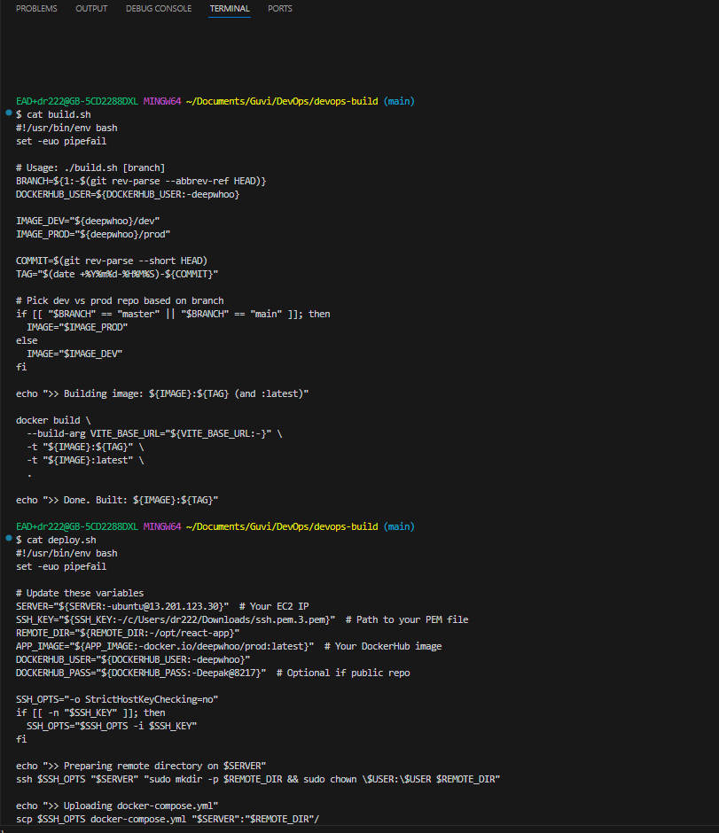

Step 26: React app running on port 80

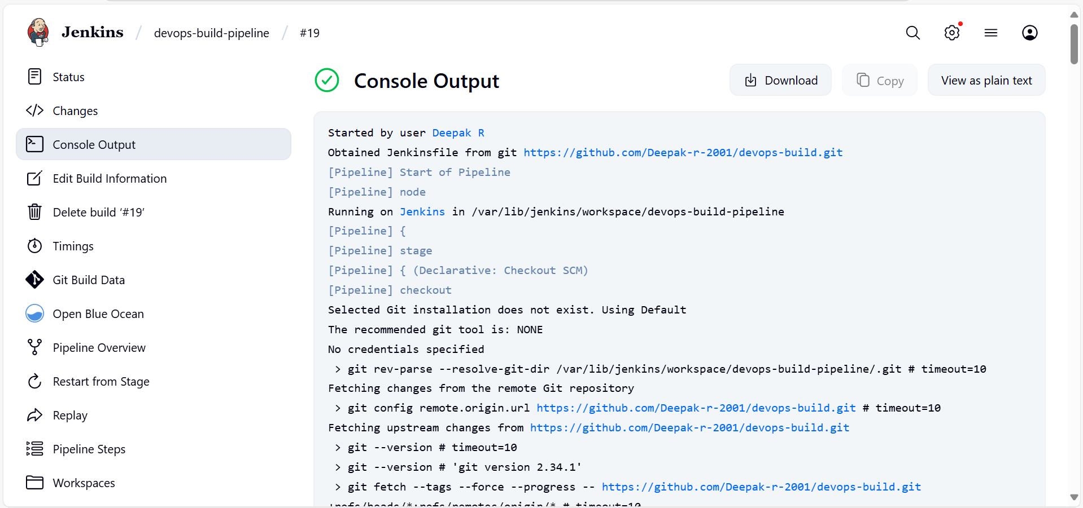

Step 27: Docker Compose configuration file

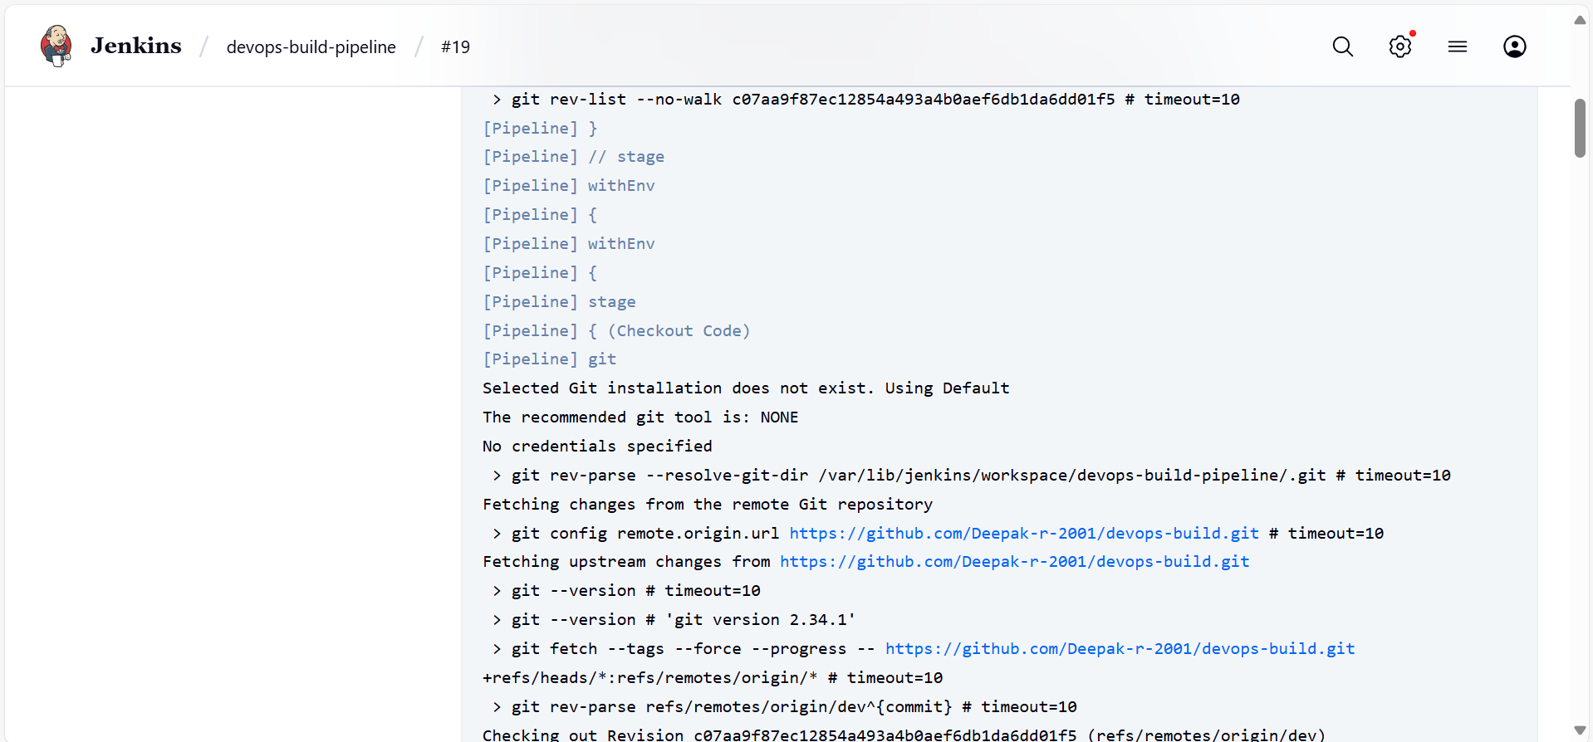

Step 28: Dockerfile for React application

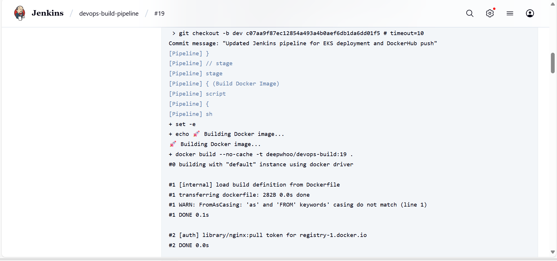

Step 29: Jenkinsfile for CI/CD pipeline

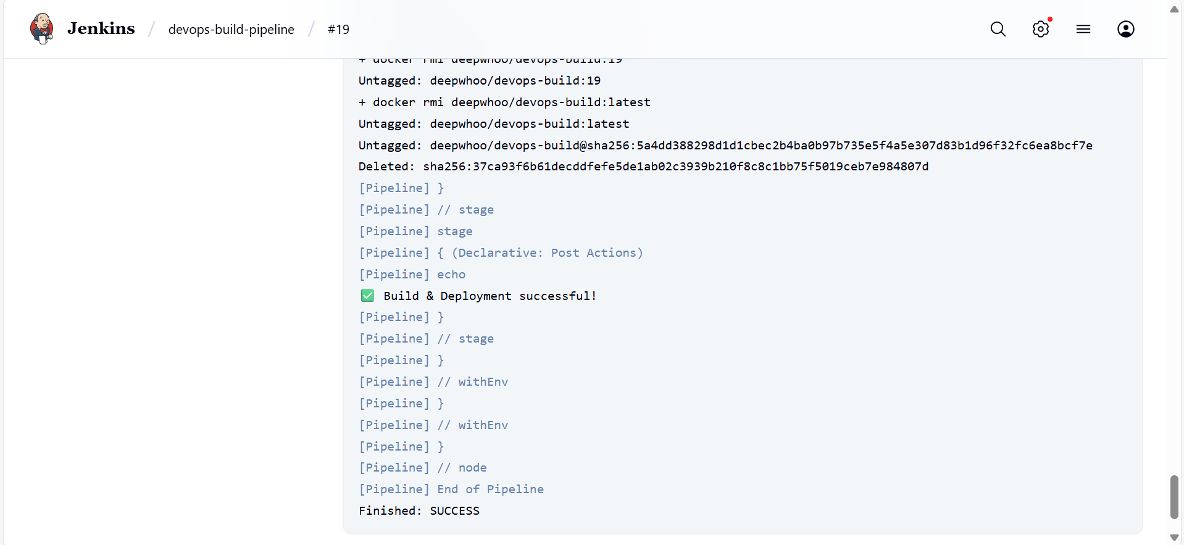

Step 30: Prometheus configuration file

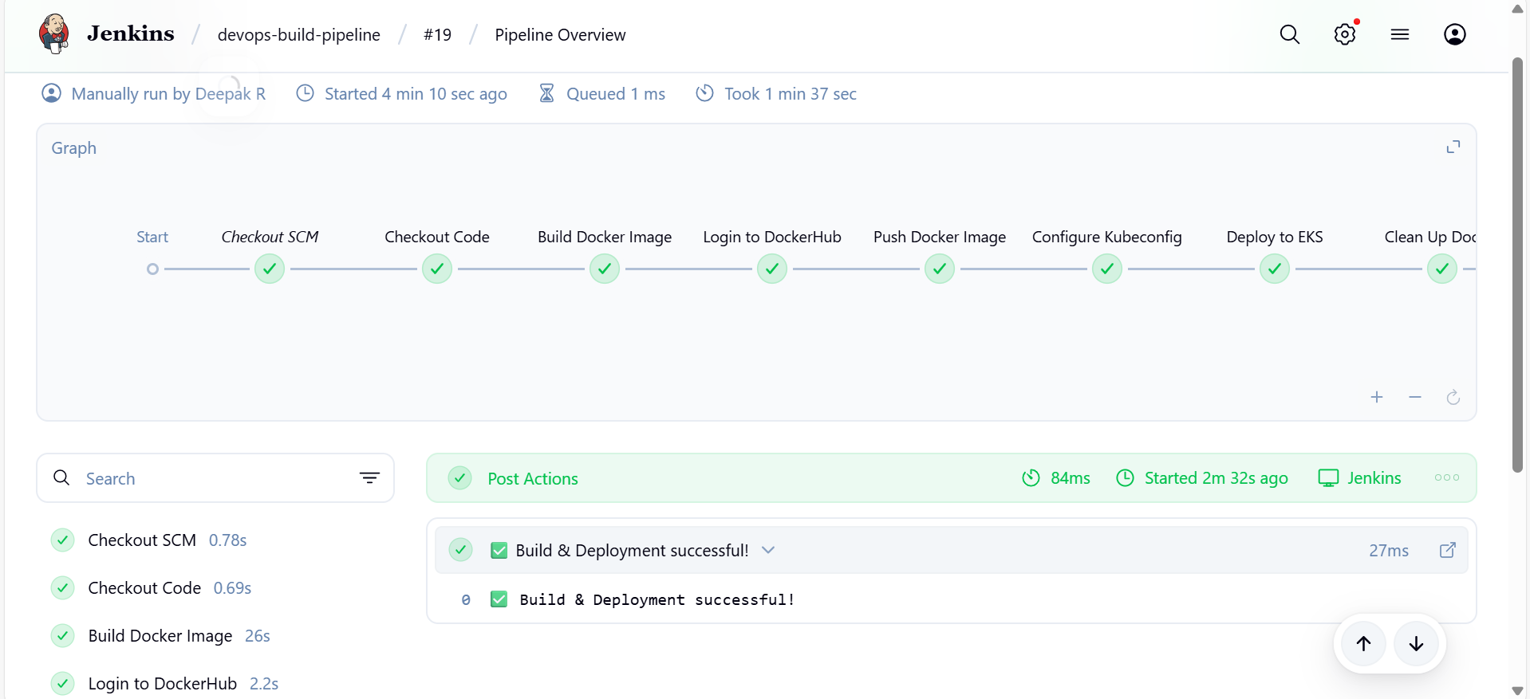

Step 31: Grafana dashboard configuration

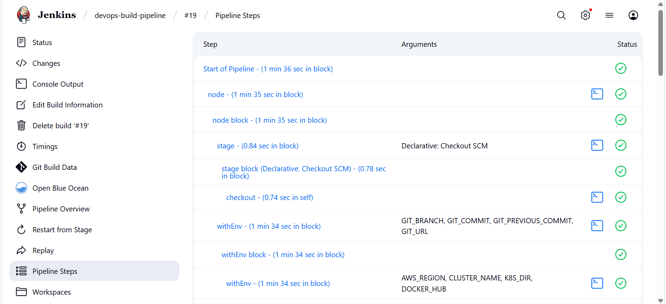

Step 32: AWS EC2 instance overview

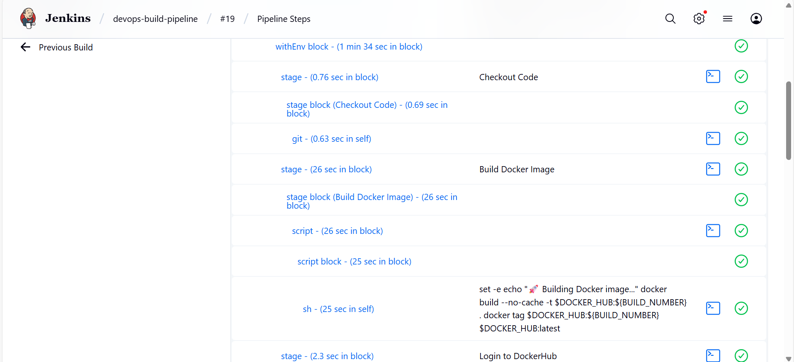

Step 33: Application logs in container

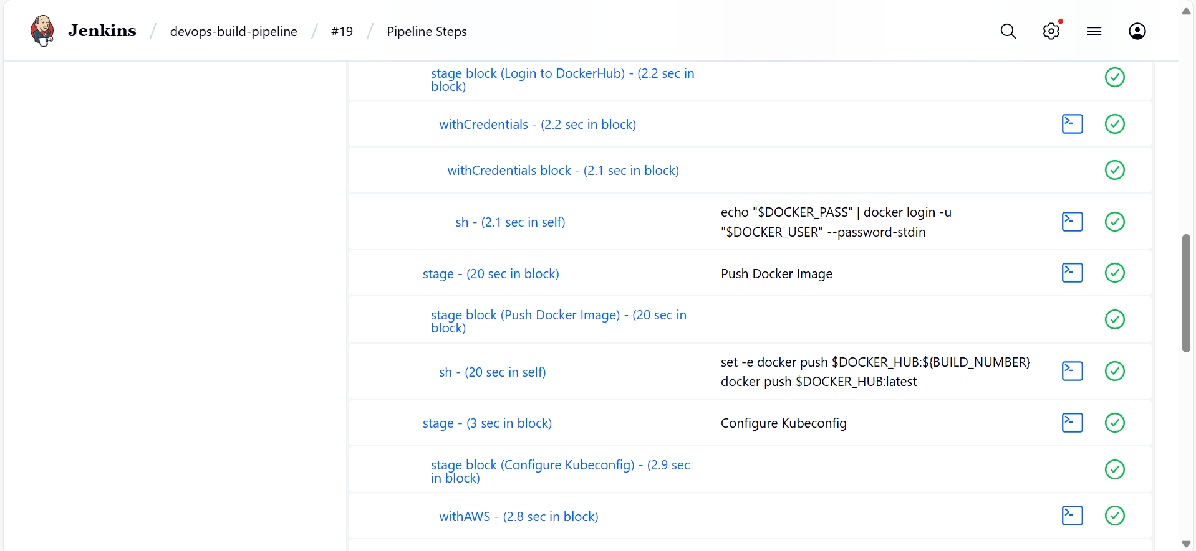

Step 34: Final deployed application dashboard

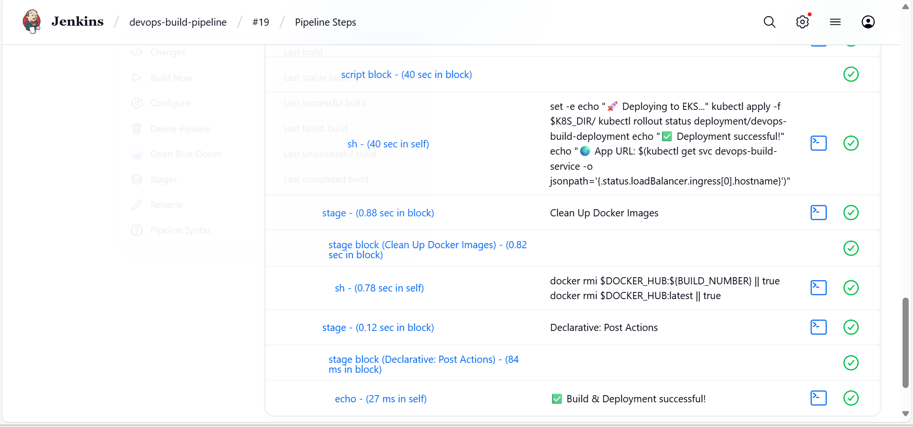

Step 35: Overall project monitoring dashboard

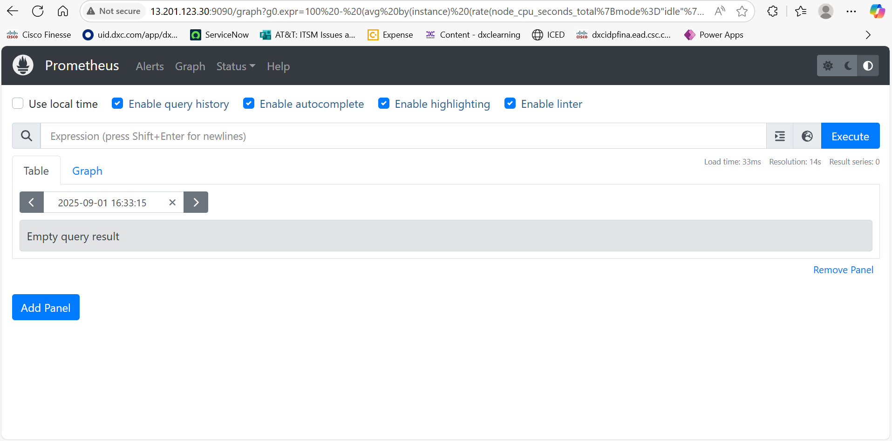

# Conclusion

This project successfully demonstrates deploying a React application in a production-ready environment using Docker, Jenkins, AWS, Prometheus, and Grafana. The automated CI/CD pipeline ensures smooth development and deployment, while monitoring provides real-time insights into application performance.